**3GPP TSG RAN WG1 Meeting #86bis R1-1609338**

**Lisbon, Portugal, 10th - 14th October 2016**

**Agenda Item: 8.1.3.1**

**Source: MediaTek Inc.**

**Title: Resolving Polar Code Memory Complexity Issue**

**Document for: Discussion and Decision**

# Overview

Although Polar code is proven to be a capacity achieving coding, one major debate on its applicability is the large decoder memory complexity. In particular, the memory complexity of Polar decoder is of O(L∙N), where L is the SCL decoder list size and N = 2n is the mother code bit length. Without fundamentally scaling down the memory complexity, Polar is regarded as inadequate for NR data channels with larger codeblocks [1].

Based on a recently proposed solution in [2], we would like to show **the Polar code memory complexity issue can be effectively resolved via subcode-wise Polar encoding and decoding**. Specifically, the memory complexity can be reduced from O(L∙N) to O(L∙N/M + N) where M is number of subcodes with reduced size of N/M. **For a list-8 Polar decoder dealing with N-16384 Polar code, the memory complexity can be reduced to 18.8% with 16-subcode segmentation**. Another useful application of the design in [2] is to enable decoding large codeblocks via reusing a small Polar decoder to perform subcode-wise decoding. In [3], it is shown that **a small Polar decoder can effectively cover large codeblocks of 8192 info bits with <15% area of the corresponding LDPC decoder**. This makes Polar decoder one very area-compact solution to handle low data rate downlinks in most of UE daily use.

This contribution is organized as follows. In Section 2, subcode-wise Polar encoding and decoding is introduced with more details of a specific design provided in the Appendix. In Section 3, performance verification for the subcode-wise Polar encoding and decoding is conducted. In addition, the advantage of the Polar code over LTE TBCC is examined. Finally, the contribution is summarized in Section 4.

# Encoding and Decoding Design

Regarding that a Polar code exhibits very systematic structure, one can view it as multiple Polar subcodes interconnected via an inner polarization structure, as illustrated in Fig. 1 with 4 subcodes.

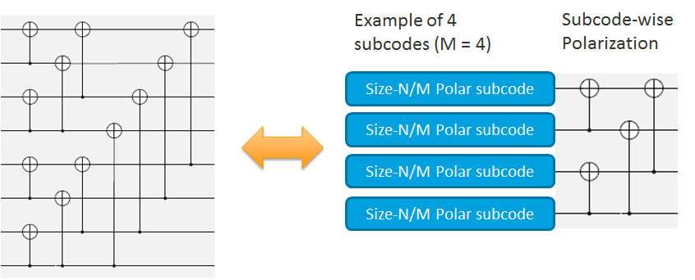

Fig. 1: Viewing a larger Polar code as interconnected Polar subcodes

In the decoder side, such viewpoint can imply a low-complexity hybrid decoding where **SCL decoding is applied subcode-wise while simple SC decoding is used across subcodes to exploit the polarization gain**. By making hard decision after each subcode decoding, the SCL decoder complexity is confined to the subcode size. **The overall decoder complexity is therefore reduced from whole-codeblock SCL, i.e., O(L∙N), to one subcode SCL decoding plus one whole-codeblock SC decoding, i.e., O(L∙N/M + N).**

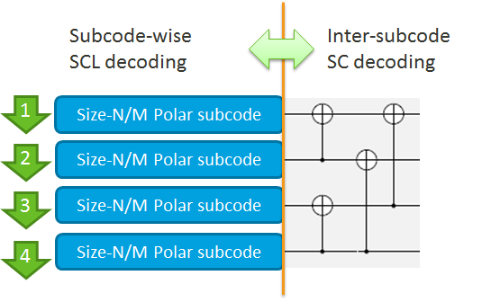

Fig. 2: Reducing complexity of whole-codeblock SCL to subcode SCL

To make subcode SCL decoding more effective, local CRC for each of the first M-1 subcodes can be applied while the last subcode can reuse the global CRC, as illustrated in Fig. 3. However, regarding the recently proposed CRC-less Polar code [3], it is also possible to eliminate the extra CRC overhead. In the Appendix, there provides a specific encoding design with local CRCs that also incorporates the low-complexity rate-matching design in [4] or [5].

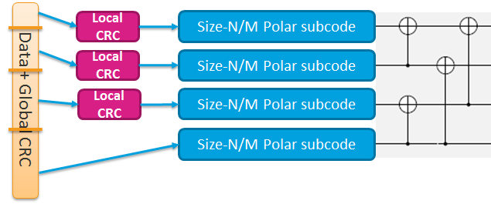

Fig. 3: Adding local CRC subcode-wise for effective subcode SCL decoding

# Performance Evaluation

In this section, the performance of the subcode-wise Polar encoding and decoding, as specified in the Appendix, will be verified. In particular, we consider a constant subcode size of 1024 and testify codeblocks of 1000 and 2000 info bits as well as extensive code rates, including ranging from 1/5 to 8/9. Figs. 4 below shows the performance loss w.r.t. the Polar codes without local CRC overhead and with whole-codeblock SCL decoding. It can be checked that confined SNR loss can be achieved even with 16-subcode segmentation, indicating the effectiveness of subcode-wise Polar encoding and decoding.





Fig. 4: Comparison of subcode-wise SCL (solid curves) and whole-codeblock SCL (dot curves)

With subcode-wise decoding, the complexity for a Polar decoder to decode larger codeblocks can be kept compact, similar to TBCC Viterbi decoder with window-based decoding. However, with polarization gain across subcodes, Polar code can realize much superior performance w.r.t. TBCC, as shown below.

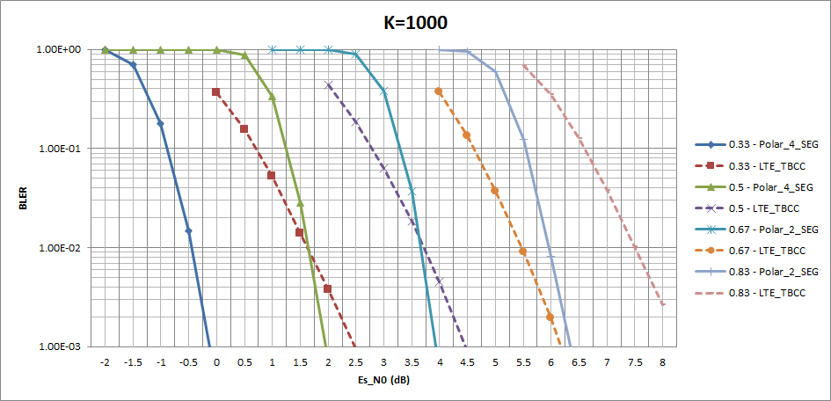

Fig. 5: Comparison of Polar code with subcode-wise SCL list-8 (solid curves) and TBCC (dash curves)

# Summary

In this contribution, subcode-wise Polar encoding and decoding is introduced as an effective solution to resolve Polar code memory complexity. By turning the whole-codeblock SCL decoding into subcode-wise SCL decoding, the memory complexity can be reduced from O(L∙N) to O(L∙N/M + N), where M is the subcode number with reduced size of N/M. For SCL list-8 decoder to decode an N-16384 codeblock, the complexity can be reduced to 18.8% with 16-subcode segmentation. Reversely, a small Polar decoder can be reused to effectively decode larger codeblocks. Consequently, the following proposal is suggested:

**Proposal 1: Polar code with subcode-wise Polar encoding and decoding can effectively cover small to large codeblocks with much reduced memory complexity. Together with its performance advantage over TBCC, Polar should be utilized to cover all NR low data rate downlinks, including control channels, so that only a single area-compact decoder need turning on during most time of UE daily usage.**

**References**

1. R1-164360 “Analysis of candidate code types for long block length”, Ericsson
2. M.-C. Chiu and W.-D. Wu “Reduced-Complexity SCL Decoding of Multi-CRC-Aided Polar Codes”, on-line available: <http://arxiv.org/abs/1609.08813>
3. R1-167215 “Channel coding for control channels”, Huawei, HiSilicon
4. R1-167871 “Examination of NR coding candidates for low-rate applications”, MediaTek
5. R1-167209 “Polar code design and rate matching”, Huawei, HiSilicon

**Appendix – Subcode-wise Polar Encoding and Decoding Design**

## Encoding Design

Step 1: Construct the polar code based required information bit length K and code rate R.

The basic polar code was constructed according to [2]. The number of code bit N and the punctured coded bit P are determined by

* + N = 2n, n = ceil(log2(K/R))
  + P = N-K/R
  + Determine the punctured bitmap of size N, where value 1 indicates puncture of the corresponding bit position and value 0 denotes no puncturing.
  + Determine the frozen bitmap of size N, where value 1 indicates freezing the input value of the corresponding bit position to Polar encoder and value 0 means a variable input bit value that can used to carry one information bit. Note that punctured bits will also be fronzen bits.

Step 2: Partition the polar code of size-N into size-Ns subcodes.

The size of Ns can be adjusted according to targeted subcode decoder complexity. The number of subcodes is the determined by

* + M = min(1,N/Ns)

Step 3: Decide the proper CRC size within each subcode.

Denote  as the CRC size in subcode i subject to a predefined set , then



* +  is the number of information bits in the subcode i
  +  is the number of frozen bits in the subcode i
  +  is the number of punctured bits in the subcode i
  + B is the parameter used to keep sufficient number of information bit for CRC encoding and can be properly designed. As one example, the value is set to 8.
  + The set S can also be designed to include the available or preferred CRC sizes. As one example, we consider 

Step 4: CRC bits insertion

* + The punctured bitmap obtained in step1 is not modified. So the code rate R is not changed by additional CRC bits insertion.
  + Determine the new frozen bitmap with number of information bit = K + .
  + Insert the CRC bits into un-frozen bits with lower indices in each subcode.

## Decoding Design:

* For each subcode, the decoding can reuse the SCL decoder with a targeted list size L.
* Do the CRC check at the end of i-th subcode during list decoding if.
  + The subcode CRC can be used to decide the best information path passing the CRC.
* Perform SC decoding with the hard decision feedbacks from all subcodes with index <= i over the inner polarization structure and obtain the input to (i+1)-th subcode for SCL decoding.
* After the last subcode is decoded, utilize the global CRC to make the final data decision.